Sayed Safwan Askari 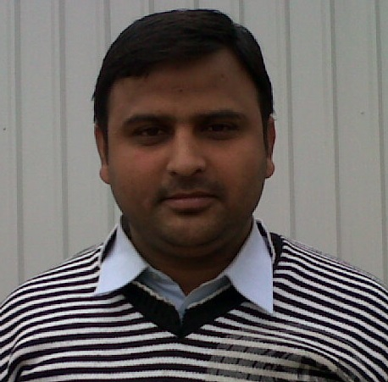
Mobile: 09918110555

Email: safwan141@gmail.com

Seeking assignments in Sales / Business Development with an organization of high repute.

Executive Summary
- Nearly 5 years’ experience in Channel Management, Sales & Marketing and Business Development in consumer durable.
- Presently working with DAIKIN Air-conditioning India Pvt. Ltd as R S O.
- Experienced in Sales plan execution, product promotion and implementation of business strategies.
- Network expansions.
- Identifying and networking with prospective clients, generating business from the existing accounts.
Organizational Details

DAIKIN Air-conditioning India Pvt. Ltd May 2014 – to Till date

RSO

- Worked as a RSO( Remote Sale Officer) at ‘Lucknow and up country
- Ensuring customer satisfaction by achieving delivery & service quality norms. Maintaining cordial relations with customers to sustain the profitability of the business.
- Enhancing market share through expanding the dealers.
- Network expansions.
- Planning and implementations of sales promo activities, Training programs for trade partners.

Videocon Industries Ltd . June’11– April 2014

RSO

- Effectively handled sales and marketing operations in the assigned region of ‘Lucknow & Upcountry with the focus on achieving sales and collections targets within the set time frame.
- Handled various operations including inventory management, timely issuance of credit notes and reconciliation of trade accounts.
- Network expansions.
- Managing Customer Relations retention and relationship management.
- Planning and implementations of sales promo activities, Training programs for trade partners.
- Enhancing market share through expanding the retail counters.
- Widening the reach of products.
- Actively involved in monitoring service franchisees for better servicing to trade and customers

MOTOR General sales auto Fab Pvt. Ltd. ( TATA MOTORS ) Aug 2009 – June 2011

Dealer sales executive

- Actively involment in rural areas time to time.
- Customer contact details to be maintained for all walk-in, telephonic enquiries & cold calls attended.
- Maintain an owner follow-up system in order to encourage repeat and referral business
- Must carry a well-equipped Sales Kit.
- Record customer details in database.
- Regularly carry out liaison with Sales administration to ensure customer vehicles are available on time and all details are accurate.
- Respond to telephone enquiries promptly and attend Walk-In Customers.
- Develops major account sales goals and strategies.
- Training programs for trade partners.
- Managing Customer Relations retention and relationship management.
- Planning and implementations of sales promo activities.
- Road show activities.
- Organize loan fair.

MOHAN MEAKINS May’08-July’08

Sales Promotion & Marketing Strategy Development

- This Training was undertaken to understand the real business situations and thus giving an opportunity to understand the theoretical concepts of making in practical work and packaging. It included the preface given by the retailers regarding scales. Analysis of sales, sales promotion consumption of liquor and the marketing strategy.

Academic Credentials

- Masters of Business Management from RITM, Lucknow in 2009.
- B.sc from ‘Lucknow University in 2007.
- Ms office , Internet Applications, Multimedia

Personal Vitae
Date of Birth : 30th June 1986
Father Name : Mr. Sayed Faiyaz Hussain,
Sex : Male
Marital status : Married
Nationality : Indian
Address : Mohalla Patel Nagar Utarula Balrampur U.P.

Sayed Safwan Askari
Date:

